Day 5 28th May

Create and remove directory “dummy”

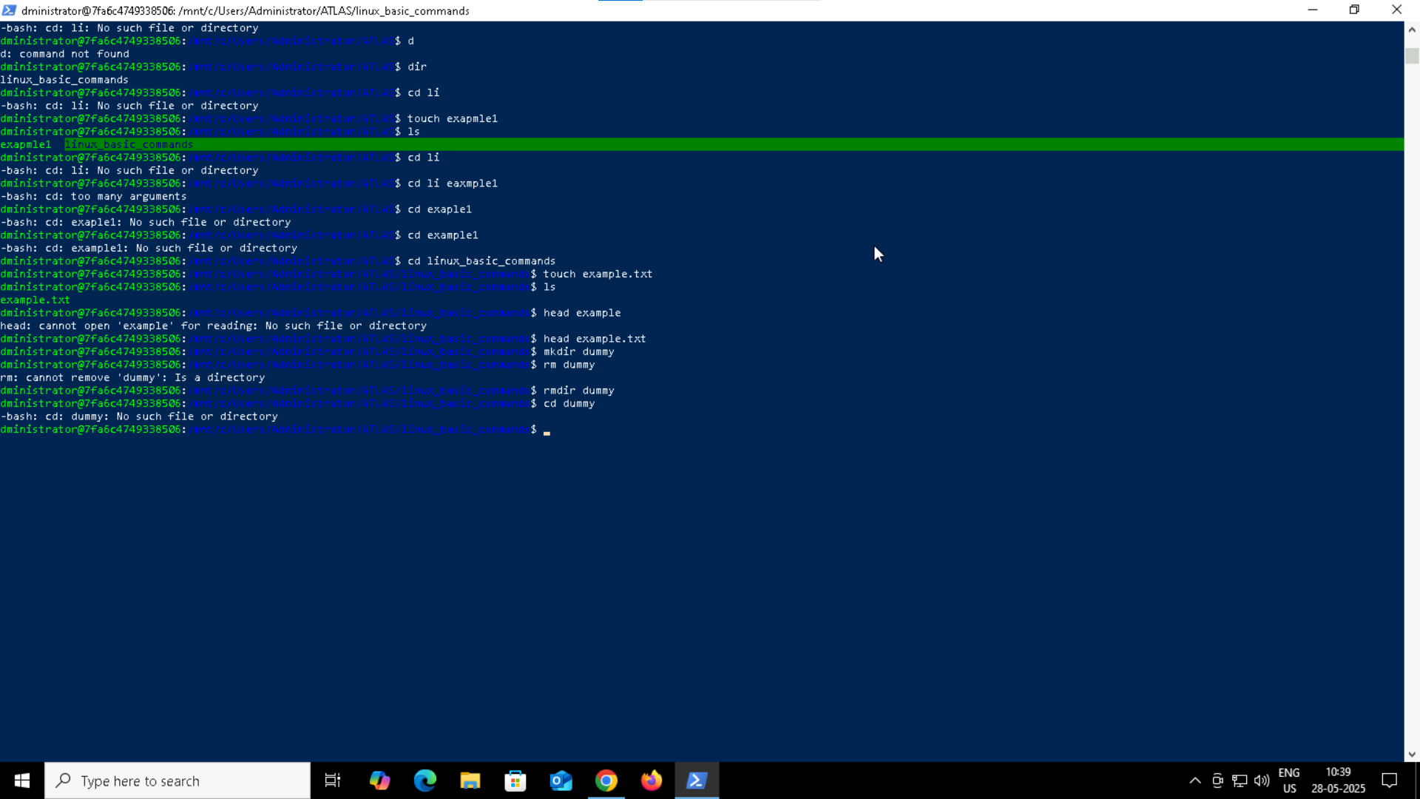

Check working directory

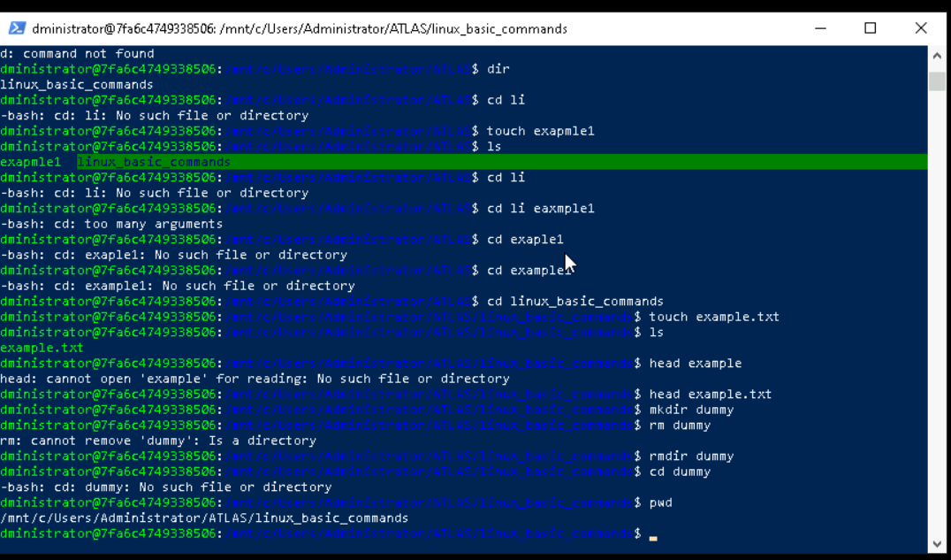

Check all the files in current directory

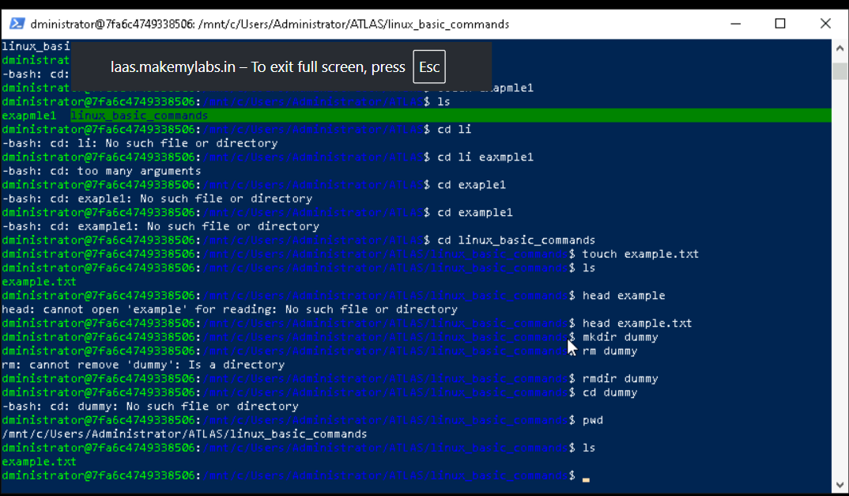

Creating a text file, writing data, appending and opening it

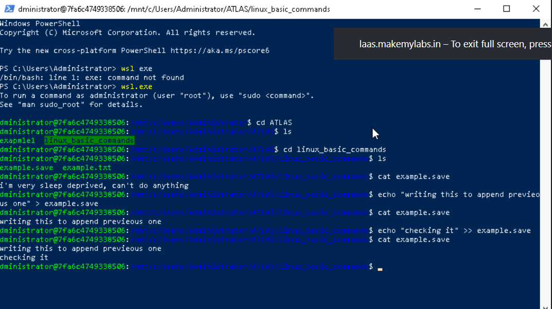

Task 7 : Create five files named TestFile2.txt.. TestFile3.txt… and so on till TestFile6.txt

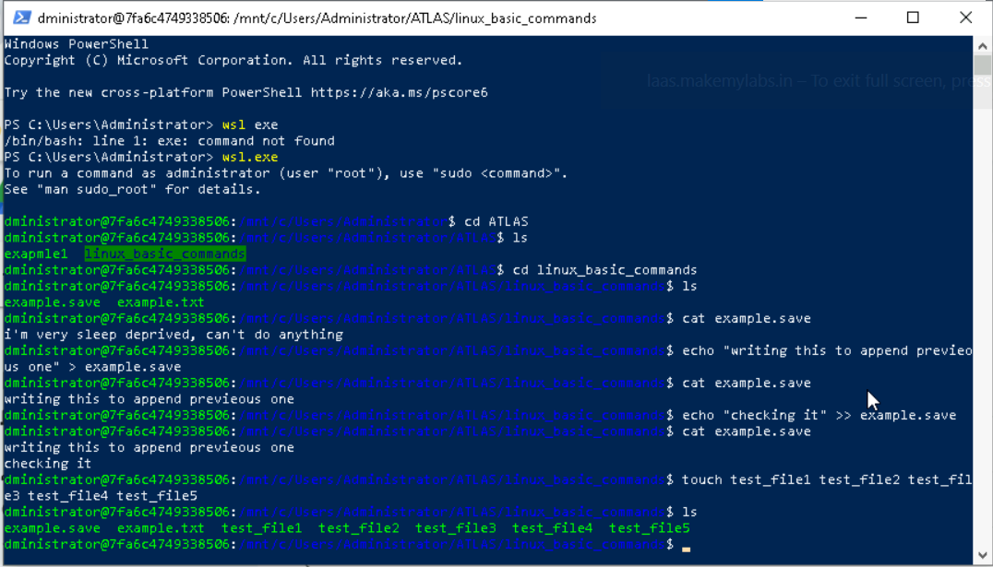

Task 8:

Copy all files from Dir 1 ti Dir 2

2 min 11.55 to 11.57

Task 9:

Move all files from Dir 2 to Dir 3 (finally ur Dir 2 should be empty)

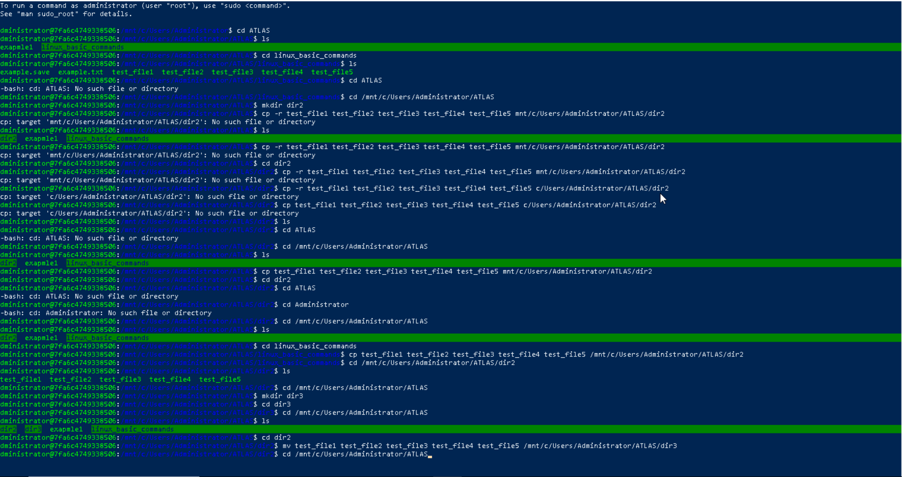

Task 10 :

Can you plz show me the diff between **rm** and **rmdir** commands with screen shots ?

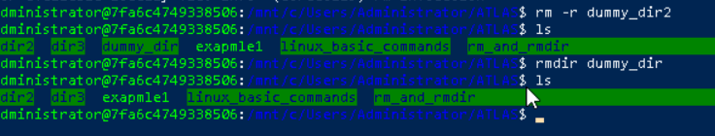

Task 11 : Now use specifically use cat command to create a file

And add the dummy text of 2 to 3 paragraphs from the above link Lorem Ipsum.

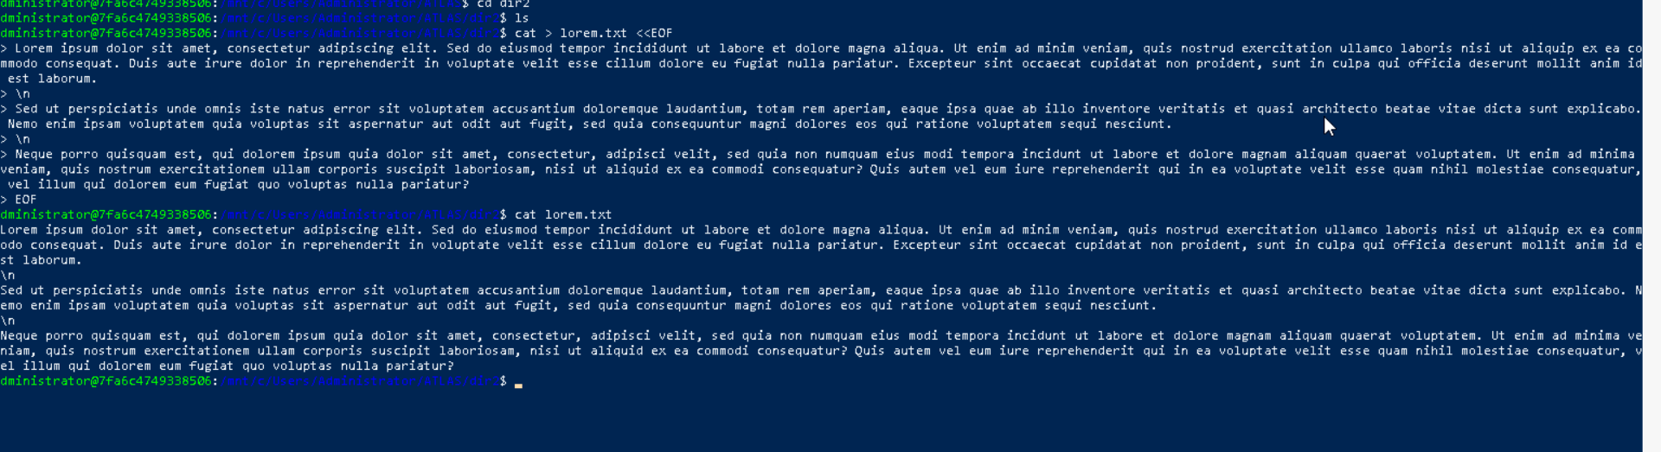

Task 12:

How to get only the top part of your file..

Task 13:

How to get only the last part of your file

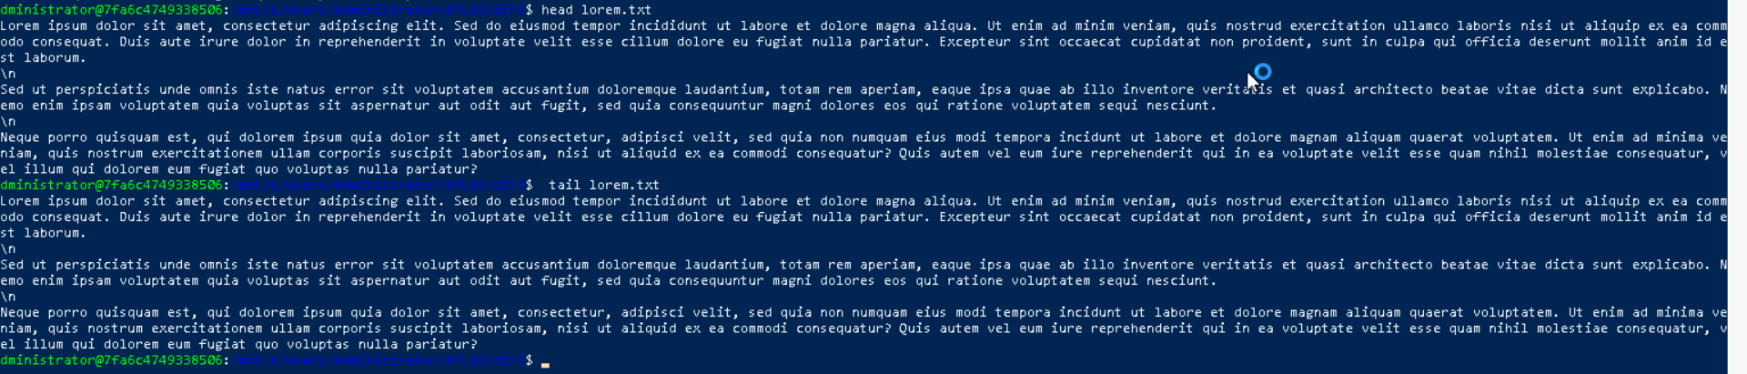

Task 14 : Plz add dummy text of 5 to 6 pages in to the same file

And

Now show the file in page by page

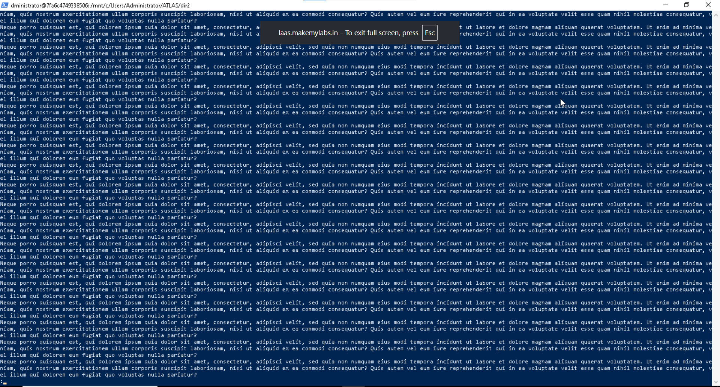

Task 15:

Use more command on the above file and find out the diff between less command and more command.

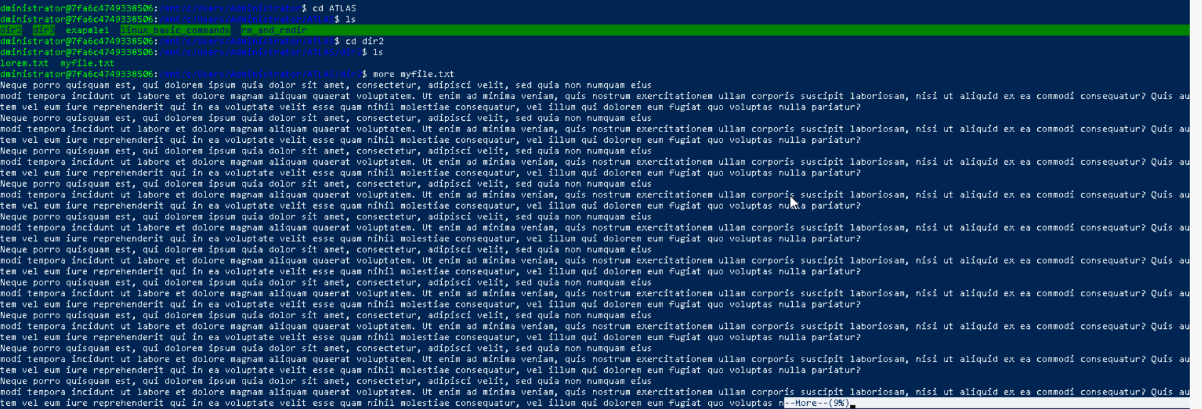

Task 16:

Can you use echo command with -e and see the diff.. Also take a ss and paste

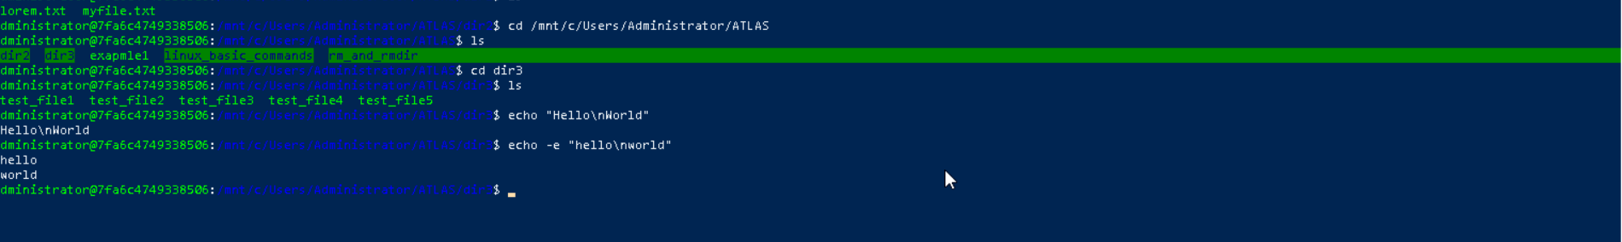

Task 17:

What is diff between ls and ls -l command .. ss plz

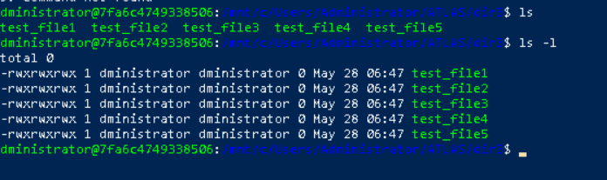

Task 18:

Create a file using **touch** command , **cat** command and **echo** command and take ss (screen shot)..

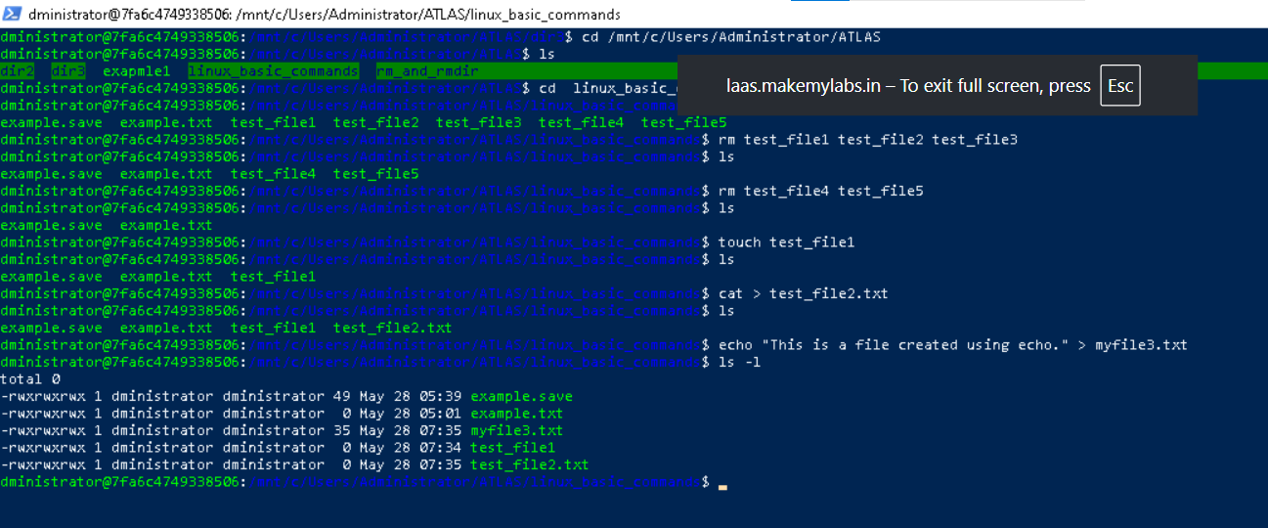

Touch : will create a file

Cat : will create a file and allow us to add data into that file then we can save and exit the file

Echo : we can create file and write data at the same time.

Task 20:

Can you go back to 1 directory .. at a time whats the command

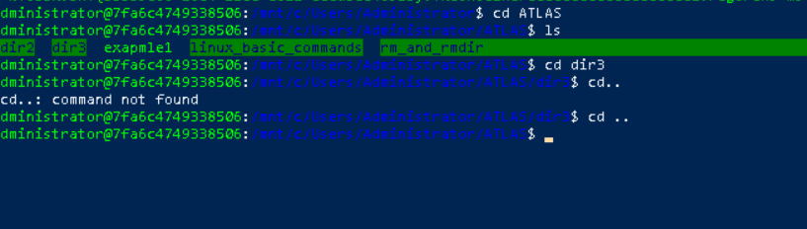

Task 21 : How to know whose user u are working on ?

Hint: use whoami command



Task 22:

Try to find out who is peeping into your system..

Use users, who and w commands with ss

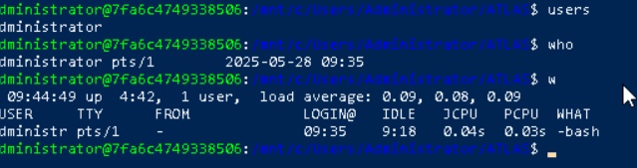

Task 23:

Can you guys try to check how much disk space is consumed..

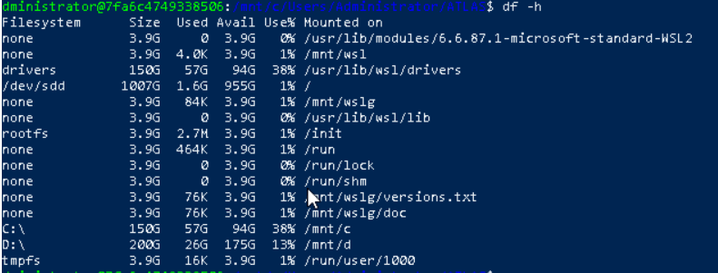

Task 24:

Can you plz try using the below commands

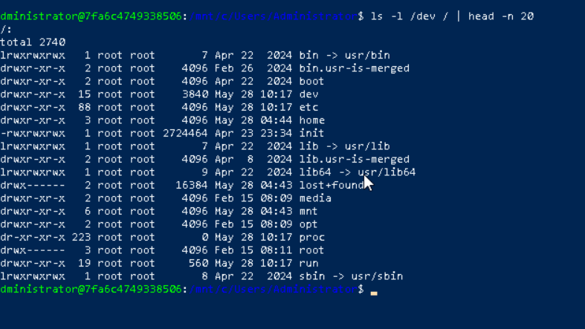

Task 25:

Find the list pf all files ending with .txt

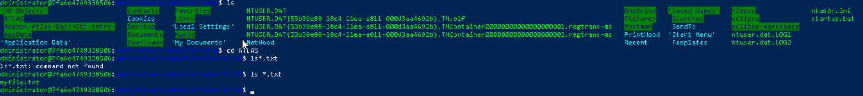

Task 26:

In Linux all the hidden files starts with . (period)

How to check all the hidden files in Linux..

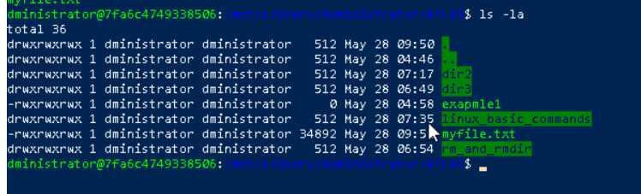

Task 27:

What is the difference between . and .. in linux

Line 1 line for each

. refers to current directory

.. refers to parent directory

Task 28:

Can you create a file using vi editor and show the details in ss

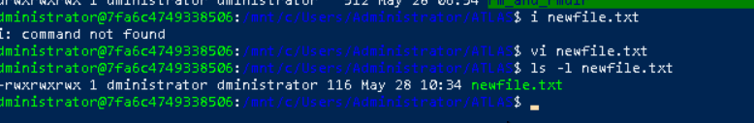

Task 29:

How to find the no of words in the file

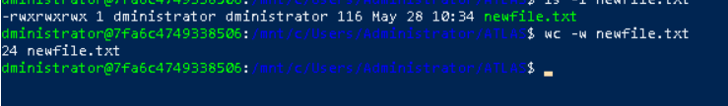

Task 30 :

What is the use of cat -b myfilename.txt command?

Is used to display the contents with non blanked lines numbers.

Task 31:

Can I use the wc with 2 or more files?

Yes, we can use wc on multiple files.

Task 32:

How to copy content of one file to another file



Task 33:

Now I want to rename my file with MYFILENEW can i do that if so how

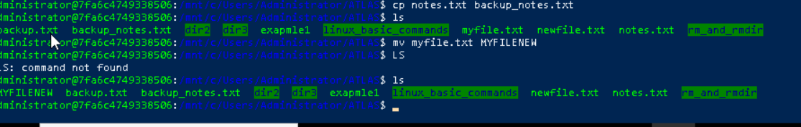

Task 34 : Can i remove or delete multiple files in linux..? How?

Yes, we can delete multiple files by using rm file1.txt file2.txt

Task 35 : In directory / slash is root … can you try cd / what is it doing?



Task 36 : Task 36:

What is the way go go to home directory ?

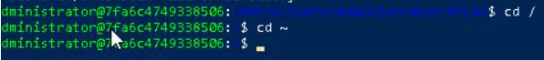

Task 37:

If i want to move to different users home directory

